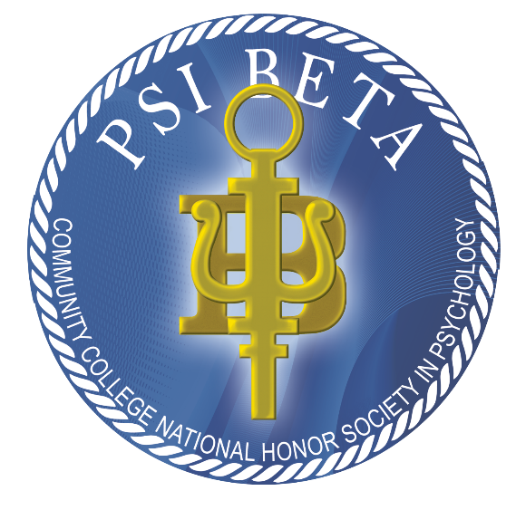
PSI BET at
Wenatchee Valley College Omak

Psychology honor society and club
We meet the1st and 3rd Thursday of each month at 3:00 PM

MET 1326 and over Teams using the QR code ion:
Join the meeting now
Meeting ID: 280 322 409 436 1
Passcode: F8Nk7Bm2
Email Advisor J’Lene George for more information jgeorge@wvc.edu
The club offers psychology related services, activities, information for transfer and careers, leadership opportunities, fun, and more. You do not need to be a psychology major. Everyone is welcome to participate in psychology club. Those with a 3.25 GPA and B or better average in one or more psychology classes can be inducted into the Psi Beta at WVC honor society.

Wenatchee Valley College is committed to a policy of equal opportunity in employment and student enrollment. All programs are free from discrimination and harassment against any person because of race, creed, color, national or ethnic origin, sex, sexual orientation, gender identity or expression, the presence of any sensory, mental, or physical disability, or the use of a service animal by a person with a disability, age, parental status or families with children, marital status, religion, genetic information, honorably discharged veteran or military status or any other prohibited basis per RCW 49.60.030, 040and other federal and state laws and regulations, or participation in the complaint process. The following persons have been designated to handle inquiries regarding the non-discrimination policies and Title IX compliance for both the Wenatchee and Omak campuses: To report discrimination or harassment: Title IX Coordinator, Wenatchi Hall 2322M, (509) 682-6445, title9@wvc.edu. To request disability accommodations: Director of Student Access, Wenatchi Hall 2133, (509) 682-6854, TTY/TTD: (509) 682-6853, sas@wvc.edu.

