
Accident Report Form Questions?
Must be filled out and submitted within two days of accident Contact Administrative
or discovery of an occupational illness Services at 509.682.6514

Use this form to report workplace injury accidents, an occupational illness or any other accident to an employee, student or visitor that involves an injury on the WVC campus OR to an employee or student off campus during working status. Provide detailed information and complete the form as accurately as possible. Submit the completed and signed form to the department supervisor for review and signature. Signatures are required on this form prior to being submitted, unless the affected party is unable to sign at the time of the accident, then follow up will take place at a later date. The accident form must be submitted directly to Heather Maddy, Administrative Services, Third Floor, Wenatchi Hall.

Person Affected by Workplace Injury, Accident or Report of Occupational Illness
Name (please print): |  | Phone: |  |  |  |  | Email:
Address:
Date of Birth: Hire Date: Gender: Male Female
Type: Employee Student Employee Student Volunteer Visitor Other:
Injury/Accident/Illness Details
Date of Injury or Illness: |  |  |  | Time of Event:: AM PM
Time Employee Began Work: AM PM
Accident Location (building/room/parking lot - be specific):
Condition of Accident Site (wet, dry, icy, dark, other):
Clearly describe what happened (e.g., cut to left hand index finger while using a hand grinder) and circle the injury location(s) on the figures below. Use the back of form if needed.
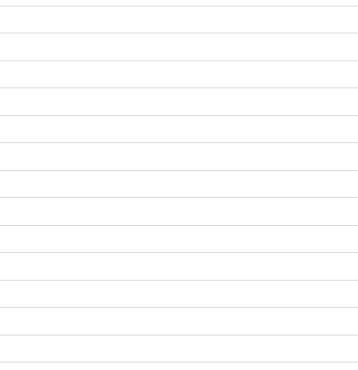 |  |  |  |  | 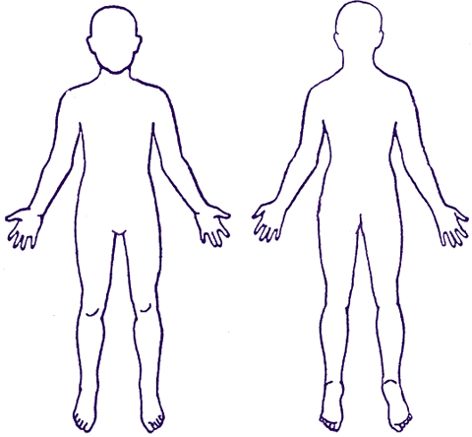
Medical Treatment/Assistance (check all that apply)
None Required First Aid (returned to class/work) First Aid (sent home) Private Physician Emergency Room
Medical/Dental (including clinic/hospital outpatient treatment) Hospitalized (admitted as inpatient) Other:
Who provided treatment (list name of provider, clinic/hospital)?
Person Reporting Accident (if different than person affected)
Name: |  |  | Phone: |  |  |  | Email:
Address: |  |  | Date Reported: |  |  |  | Time Reported: AM PM
Witnesses (attach statement for each)

Name: | Phone: |  |  |  |  | Email:
Name: | Phone: |  |  |  |  | Email:

Possible Causes
Equipment | Environment | Policies/Procedures | Human Factors
Defective Tools/Equipment  Defective Material  No Guards/Barriers  Inadequate Guards/Barriers Using Equipment Improperly  Inadequate Maintenance  Improper Personal Protective Equipment (PPE)  Lack of PPE  Other (explain) __ | Inadequate Poor Housekeeping  Ventilation Inclement Weather  Inadequate Slippery/Uneven or Excessive surface  Illumination Ergonomics Issues  Air Contaminants Sharp Objects  Chemicals Hot Objects  Noise Hot weather conditions  Fire Cold weather cond.  Explosion Animal Action  Other (explain) __ | Failure to Follow Procedures  Appropriate Procedures  Non-existent  Inadequate Instructions/ Procedures  Inadequate Planning/ Preparation  Inadequate Support/ Assistance  Other (explain) __ | Inadequate Training Verbal Assault  Inadequate/ Improper Physical Assault  Protocols/Procedures/ Inattention  Expectations/PPE Loss of Balance  PPE Not Used Rushing  Improper Lifting Phobia/Anxiety  Failure to Follow Horseplay  Established Protocols/ Other  Procedures (explain) __
Suggested Corrective Actions by the Affected Party
Provide safety training Change/review work procedures Submit work order for maintenance/repair
Undertake hazard assessment Provide protocols, procedures and expectations Change work area layout/design
As you are the affected party, what actions could you have taken to prevent the injury from occurring?

Signature(s)
Signature of Affected Party Date |  | Signature of Person Reporting Accident Date

The following sections to be filled out by WVC management

Supervisor Comments and Signature
Possible Cause(s):
(As the supervisor, please identify one or more of the factor(s) that may have contributed to the accident, including equipment, policies, procedures and/or personnel.)

As the supervisor, please identify the recommendation(s)/preventive measure(s)—Identify at least one:

Name and Title (please print): |  |  | Signature: |  | Date:
Safety Officer Comments and Signature
Possible Cause(s):
(Please consider any factor(s) that may have contributed to the accident, including equipment, policies, procedures and/or personnel.)

Recommendation(s)/Preventive Measure(s):

Name and Title (please print): |  | Signature: |  |  | Date:
V.P. of Administrative Services |  |  |  | Human Resources
Signature: | Date: |  |  | Number of Days Away From Work:

